Project Report

Train Ticket Booking System

SUBMITTED BY: SARAH KUNDU
SAP ID: 590023804
BATCH NO. 60
C PROGRAMMING

ABSTRACT
This project is a console-based Train Ticket Booking System written in C language. It allows the users to look for train routes, check if there are available seats, provide passenger info, and reserve the ticket. Basic input verification is done by the system, the status of the booking is shown, payment confirmation is taken care of, and at last, an e-ticket with necessary travel details is created.

The project is a showcase for the use of conditional statements, string control, user input processing, and structured flow of the program. Additionally, it brings to light a practical use of C in the development of elementary reservation systems.

PROBLEM DEFINITION
The concept of the project is to simulate a basic ticket booking process which is like an actual railway reservation system. The following steps are to be taken:
- Search for the train routes (From → To)
- Select the traveling class
- Inquire about the availability of the seats
- Enter the personal and journey details
- Make the payment and get confirmed
- Get a final ticket along with PNR and travel details
The objective of the system is to get rid of the problem of a simple, user-friendly reservation logic that is built using C programming fundamentals.

ALGORITHM
- Start the program.
- Ask user for destination and source.
- Ask user to choose travel class.
- Check seat availability and display booking status.
- Ask user to enter date of journey.
- Collect passenger details such as name, age, gender, and berth preference.
- Show ticket price and ask for payment confirmation.
- If confirmed, print ticket with PNR; else exit.
- End the program.

IMPLIMENTATION DETAILS

Tools & Technologies Used
- Programming Language: C
- Compiler: GCC
- Environment: VS Code

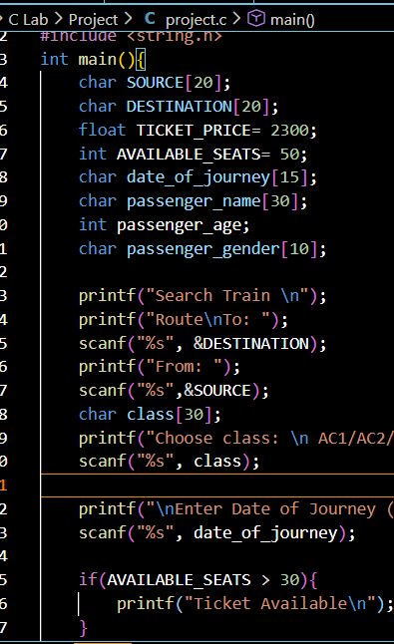

TESTING & RESULT

Sample Test Case
Input:
- To: Mumbai
- From: Delhi
- Class: AC2
- Seats Available: 50 → Output: Ticket Available
- Date: 22/12/2025
- Passenger Name: Sarah
- Age: 19
- Berth Preference: Lower
- Gender: F
- Payment: Yes
Output:
- Booking Confirmed
- Payment Successful
- E-Ticket Generated with PNR

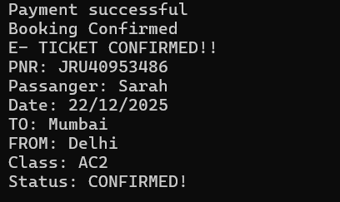

CONCLUSION
The Train Ticket Booking System successfully simulates a simplified reservation workflow, demonstrating practical use of C programming constructs. It provides a structured and interactive experience for users.

REFERENCES
- Let Us C — Yashavant Kanetkar
- Railway Reservation System examples and tutorials

